Polarization Maintaining Isolator

Features
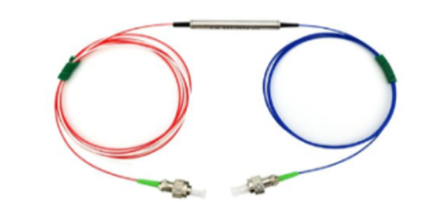

- Low Insertion Loss
- High Extinction Ratio and High Isolation
- Available for Slow or Fast Axis App
- High Stability and Reliability

Applications
- EDFA
- Fiber Optical Instrument
- Fiber Laser
- Fiber Sensor

Specifications

_{Parameters} ^{Type} |  | Unit | Single Grade |  | Daul Grade
 |  | Unit | P | A | P | A
Operating wavelength |  | nm | 1310,1480 ,1550
Bandwidth |  | nm | ±20
Peak Isolation |  | dB | 42 | 40 | 58 | 55
Isolation@at 23℃ |  | dB | ≥28 | ≥26 | ≥48 | ≥45
Insertion Loss@at 23℃ |  | dB | 0.4 | 0.5 | 0.5 | 0.6
Insertion Loss@-5 ~70℃ |  | dB | ≤0.55 | ≤0.65 | ≤0.55 | ≤0.80
Extinction Ratio | Type1:Fast axis blocked | dB | ≥20 | ≥18 | ≥20 | ≥18
Extinction Ratio | Type2:Both of axis working | dB | ≥25 | ≥23 | ≥25 | ≥23
Return loss |  | dB | ≥55
Power handling |  | mW | ≤300
Fiber Type |  | / | Corning PM Panda fiber
Fiber Length |  | / | 1310nm :PM 1310;1550nm:PM1550;
Operating temperature |  | ℃ | -5 ~ +70
Storage temperature |  | ℃ | -40 ~ +85
Dimensions |  | mm | φ5.5 × L35(P1) (only for bare fiber or 900um loose)
 |  | mm | L90*W20*H10（ABS）(P2) (only for 3mm or 2mm cable)

*Above specifications are for devices without the connectors.
*For devices with connectors, IL will be 0.3dB higher, RL will be 5dB lower, and ER will be 2dB lower.
*The PM fiber and the connector key are aligned to the slow axis, fast axis is blocked

- Package Dimension

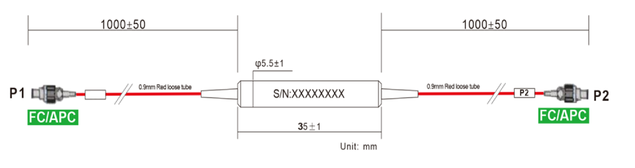

- Ordering information

PMCIR | - | XXX | XX | XX | XX | XX | XX | - | X | X
 |  | Wavelength | Type  Stage | Axis | Modules type | Fiber Type | Fiber Length |  | Com connector | Port Connector
PMISO= PM  Isolator |  | 106=1064nm | S= Single  Stage | SA=  slow axis | ST=Ф5.5X50 | 02=250um fiber | 10=1.0m |  | 0=None | 0=None
PMISO= PM  Isolator |  | 131=1310nm | P= Daul  Stage | BA=  Both axis | BX=90X20 X10 | 09=0.9mm Tube | XX=Customized |  | 1=FC/UPC | 1=FC/UPC
PMISO= PM  Isolator |  | 155=1550nm |  |  | XX=Customized | 20=2.0mm Tube |  |  | 2=FC/APC | 2=FC/APC
 |  | 165=1650nm |  |  |  | 30=3.0mm Tube |  |  | 3=SC/UPC | 3=SC/UPC
 |  | 148=1480nm |  |  |  | XX=Customized |  |  | 4=SC/APC | 4=SC/APC
 |  |  |  |  |  |  |  |  | 5=LC/UPC | 5=LC/UPC
 |  |  |  |  |  |  |  |  | 6=LC/APC | 6=LC/APC
 |  |  |  |  |  |  |  |  | X=Customized | X=Customized

Part Number | Product Description
PMISO-155PSAST10910-22(D) | PM Isolator Steel Tube Device，dual stage, Corning PM 1550nm Panda fiber with 0.9mm red loose Tube, length fiber 1m , FC/APC connector, P grade, slow axis working only

Part Number | Product Description
PMC-2215590ST10910-22(S) | 2*2 Filter PM Fiber Coupler，Splitting Ratio 90/10, Steel Tube type, PM 1550nm Panda fiber With 0.9mm Hytrel White Tube,  fiber Length 1m (with connector)， connector FC/APC，  connector key is aligned to slow axis.

